COACHING APPLICATION
MONCTON MINOR HOCKEY ASSOCIATION
2020-21 Hockey Season
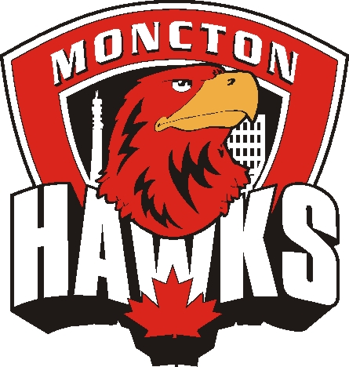
To be completed, in full, by all individuals wishing to coach a M.M.H.A. team at the Competitive level.

Name & Address
Name: |  | Phone: (H) (Cell) (W)
Coaching Position Held in 2019-2020 Season:
Coaching Position being applied for in 2020-2021 Season:
Address:
Postal Code: |  | Email:

Players in M.M.H.A.
Players Name | Year of Birth | Division & Team Last Year

Coaching Courses & Certification Attained
Intro to Coach Level 1  Date: Cert #: |  |  | High Performance 1  Date: Cert #:
Coach Level 2  Date: Cert #: |  |  | Speak Out / Respect in Sport  Date: Cert #:
Development 1  Date: Cert #: |  |  | Criminal Record and VSC  Date Obtained:
Other (please specify):

Coaching Experience (Hockey)
Year |  | Association |  | Level |  | Division |  | Coach or Asst.

Highest level of hockey played (minor, junior, university, etc)
Explain in general your coaching philosophy and style

Briefly describe your season plan

I hereby consent to the disclosure of the above information and give M.M.H.A. permission to verify any or all of the information.

Applicant’s Signature Date

Please note, at least two references must be available upon request.

